PRE REQUISITES:

IBM CLOUD SERVICE

SUCCESSFULLY CREATED IBM CLOUD SERVICES

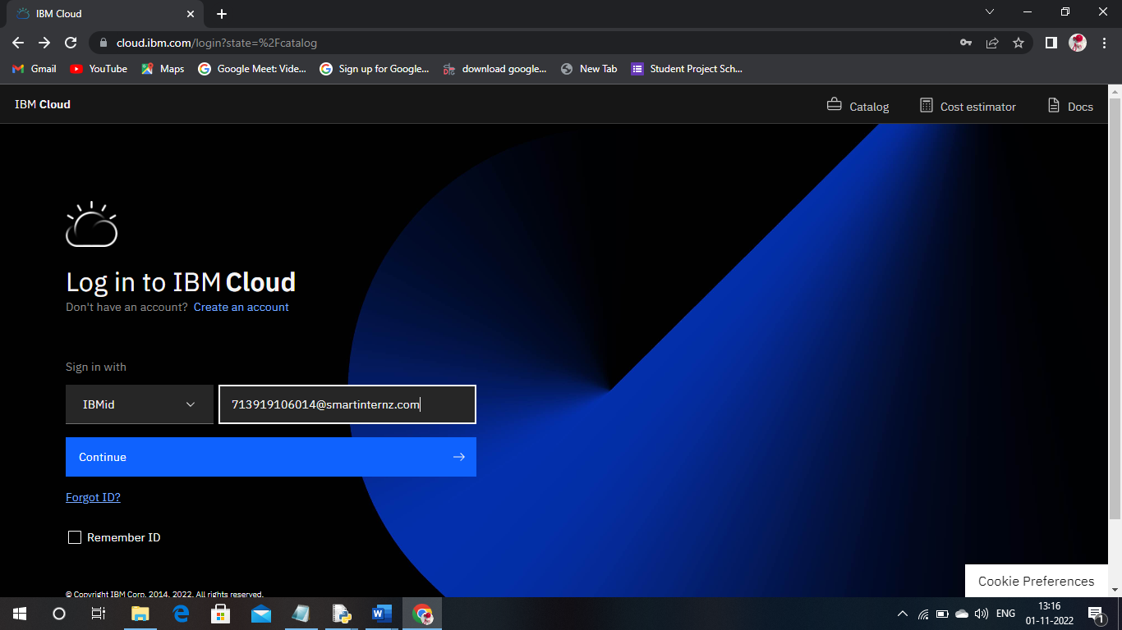

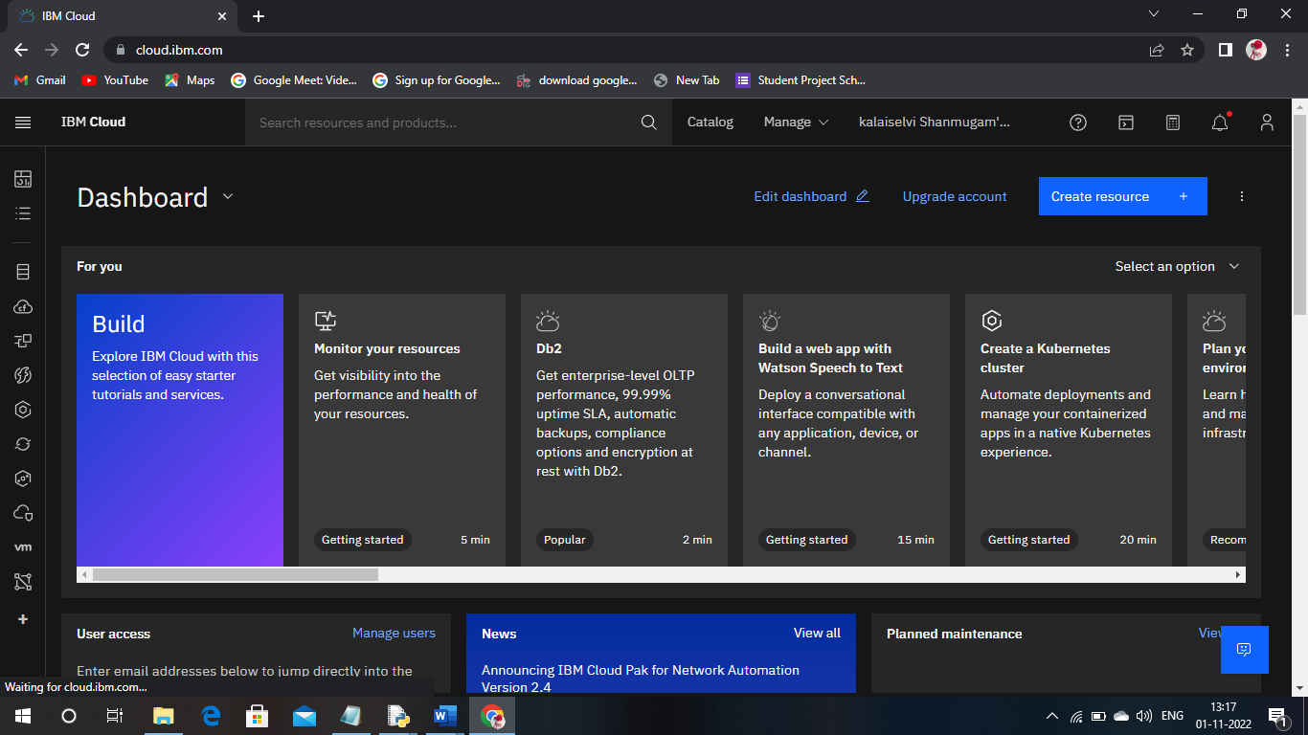

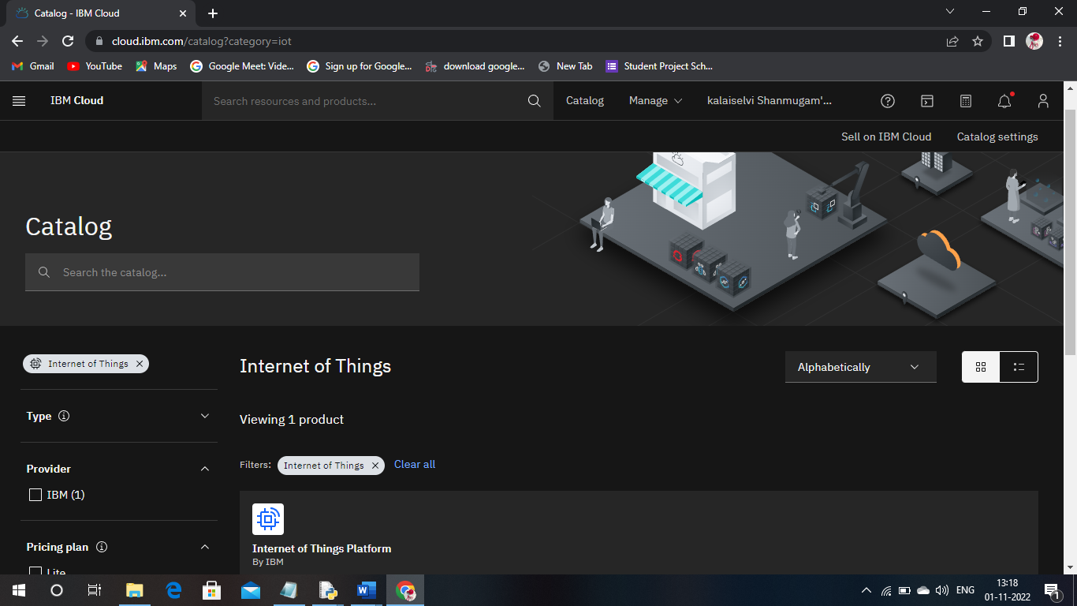

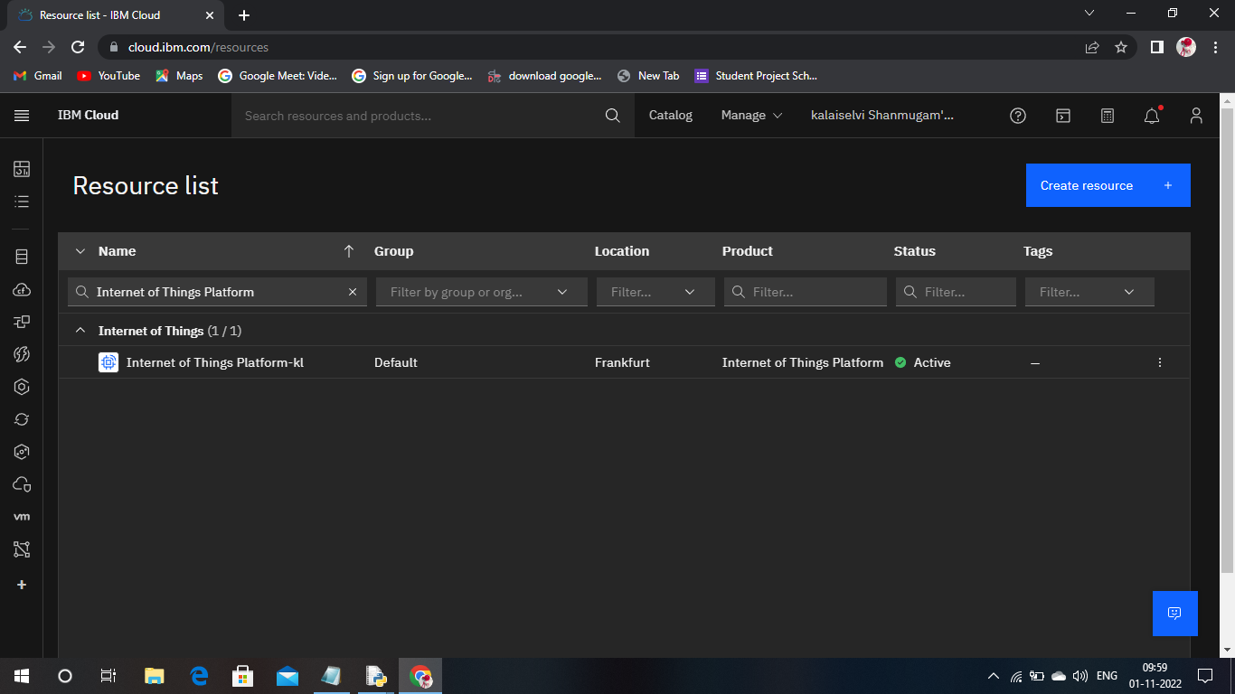

MIT APP INVENTER:

SUCCESFULLY CREATED ACOUNT IN MIT APP INVENTOR

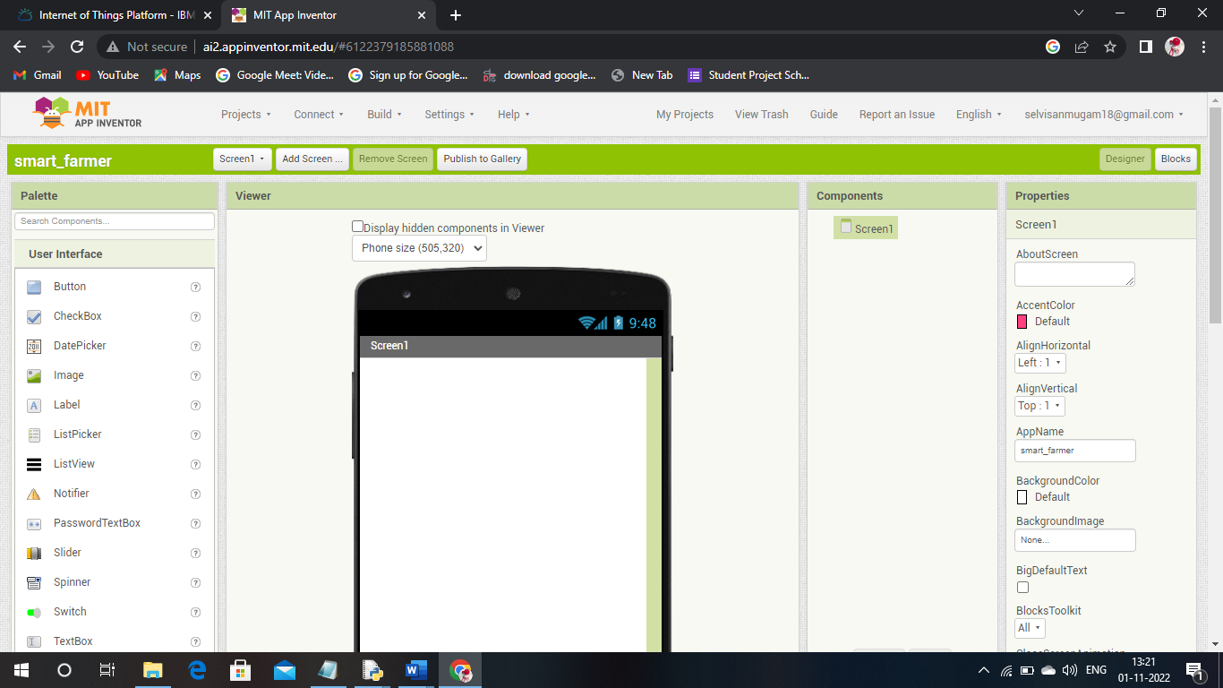

SOFTWARE:

THE REQUIRED SOFTWARE PYTHON 3.9.8 IS SUCCESSFULLY INSTALLED

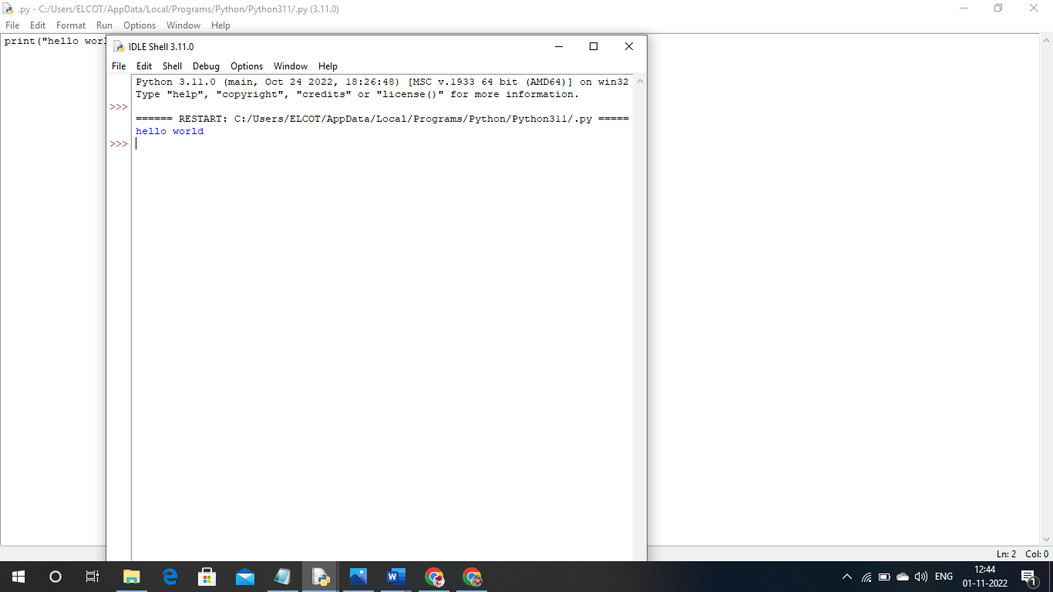

ACCOUNT IN FAST2SMS DASHBOARD:

ACCOUNT IN FAST2SMS DASHBOARD IS SUCCESSFULLY CREATED

